Morse Code Decoder Playbook

I. Challenge
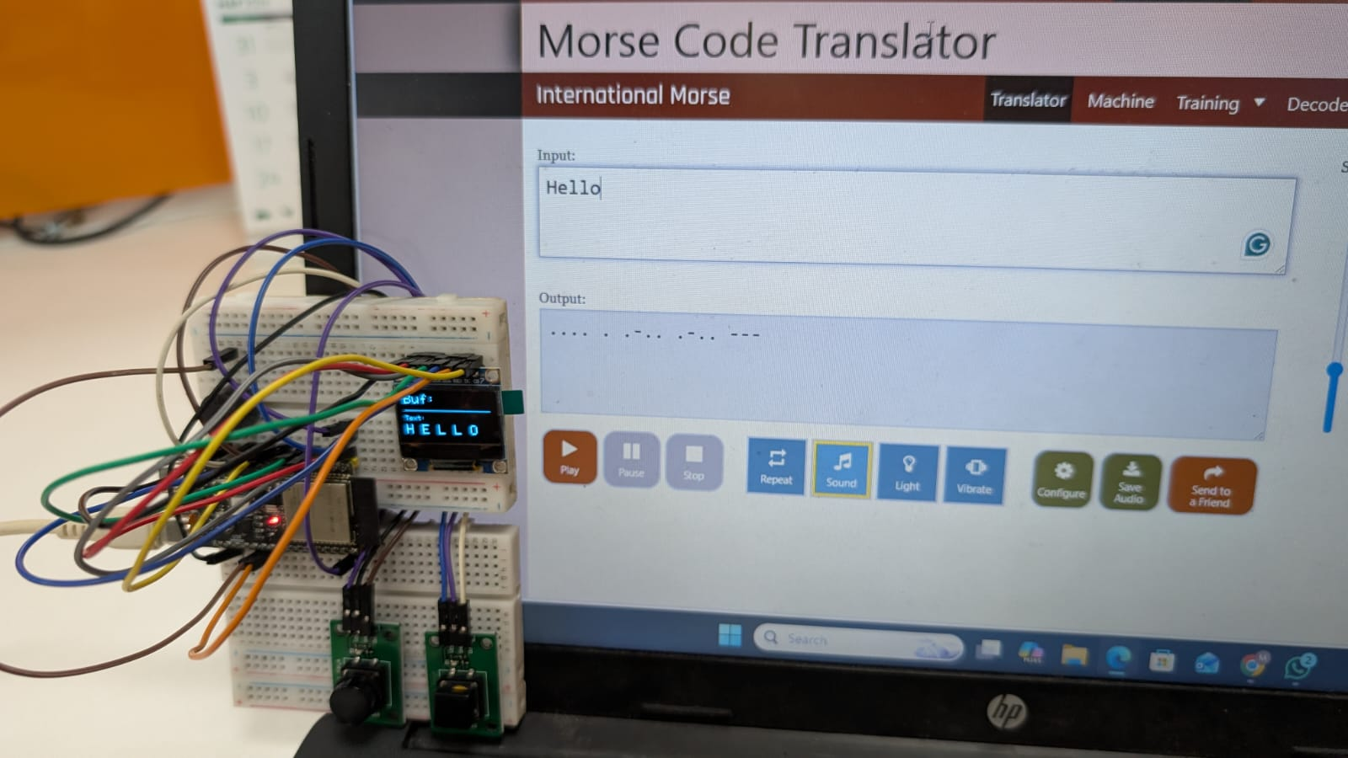
Build a non-blocking embedded communication decoder that translates real-time manual dot/dash inputs into decoded alphanumeric text. The system must process debounced digital switch state changes, manage asynchronous timing windows (millis()) for dynamic character and word boundary isolation, provide instantaneous tactile/audio feedback, and render active output buffers on an SPI OLED display with zero processor stalling.

II. Guide

A. Concept

What is Morse Code?
Morse Code is a character encoding scheme designed in the 1830s for long-distance telecommunication via electric telegraph lines. It translates standard letters, numbers, and punctuation into rhythmic sequences of two discrete signal durations:
- Dot ($⋅$): The short signal duration, serving as the fundamental unit of time measurement (1 unit).
- Dash ($-$): The long signal duration, equal in length to exactly three dots (3 units).
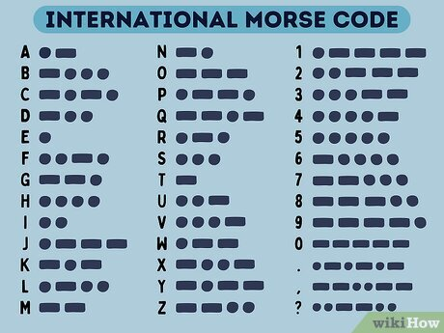
In traditional telegraphy, timing intervals between signals define words and letters: spaces between dots/dashes within a single character equal 1 unit, character gaps equal 3 units, and word spaces equal 7 units. In this embedded project, software timers (LETTER_TIMEOUT and WORD_TIMEOUT) automatically group dot/dash inputs and convert them into standard ASCII characters.

i. Underlying Engineering Principles & Reference Links
- Asynchronous Non-Blocking Event Loops (millis() Timing): Using rigid delay() functions freezes microcontrollers and misses subsequent switch presses. Polling timestamps via millis() allows the system to continuously check inputs while evaluating background timers for letter timeouts ($1000\text{ ms}$) and word spaces ($3000\text{ ms}$).
  - Learn More: Arduino Documentation – Using millis() for Non-Blocking Timing
- State-Change Edge Detection: Measuring continuous button levels triggers repeated inputs every millisecond a switch remains depressed. Edge detection tracks transitioning states ($\text{HIGH}→\text{LOW}$), capturing exactly one discrete event per physical button press.
  - Learn More: Arduino Documentation – State Change Detection (Edge Detection)
- Contact Switch Debouncing: Mechanical switch contacts physically bounce upon actuation, causing microsecond-level noise spikes that register as multiple false presses. Combining hardware pull-up topologies with software debounce intervals stabilizes the logic level before registering an event.
  - Learn More: Digi-Key – Guide to Switch Debouncing Principles
- Binary Tree & Dictionary Parsing: Morse code maps variable-length symbol sequences ($⋅$ and $-$) directly to fixed alphanumeric ASCII characters. Looking up encoded buffer strings against a dictionary array converts time-domain signals into human-readable text.
  - Learn More: GeeksforGeeks – Binary Search Trees and Lookup Structures
- High-Speed Bus Communication (Hardware SPI): Driving graphic displays via bit-banging consumes substantial processor cycles. Utilizing dedicated hardware Serial Peripheral Interface (SPI) buses offloads frame updates to high-speed shift registers.
  - Learn More: SparkFun – Serial Peripheral Interface (SPI) Architecture

ii. Real-World Example
Aviation emergency radio beacons, naval signal lamps, telegraphy decoders, and accessibility switch interfaces (such as assistive sip-and-puff communication pads for motor-impaired individuals). These platforms translate discrete pulse duration patterns into digital text streams.

B. Components
- Microcontroller: WeAct Studio ESP32-C6 Dev Board
- Display Interface: 0.96-inch SPI OLED Display Module (SSD1306 driver)
- Audio Transducer: Active Buzzer Module (Active HIGH)
- User Input: 2× Push Button Switches (Active LOW with internal pull-up)
- Interconnect Base: Solderless breadboard and jumper wires

C. Connections
The system operates entirely on 3.3V logic. Input push buttons utilize internal MCU pull-up resistors (INPUT_PULLUP), pulling the pin to GND ($0\text{V}$) upon activation.
Peripheral Component | Component Pin | ESP32-C6 Pin | Function / Designation
SPI OLED | GND | GND | Common Ground Plane
SPI OLED | VCC | 3.3V | Logic Power Supply
SPI OLED | SCLK (D0) | GPIO 6 | Hardware SPI Clock Line
SPI OLED | MOSI (D1) | GPIO 7 | Hardware SPI MOSI Data Line
SPI OLED | RES (RST) | GPIO 11 | Hardware Reset Line
SPI OLED | DC (A0) | GPIO 9 | Data/Command Mode Select
SPI OLED | CS | GPIO 10 | Active-Low Peripheral Chip Select
Dot Input Button | OUT / Signal | GPIO 1 | Debounced Dot State-Change Input
Dash Input Button | OUT / Signal | GPIO 2 | Debounced Dash State-Change Input
Active Buzzer | I/O / Signal | GPIO 3 | Audio Actuation Output (Active HIGH)

D. Code
1. C++
2. #include <SPI.h>
3. #include <Adafruit_GFX.h>
4. #include <Adafruit_SSD1306.h>
5.
6. // --- Display Configuration ---
7. #define SCREEN_WIDTH 128
8. #define SCREEN_HEIGHT 64
9.
10. #define OLED_MOSI 7
11. #define OLED_CLK 6
12. #define OLED_DC 9
13. #define OLED_CS 10
14. #define OLED_RESET 11
15.
16. Adafruit_SSD1306 display(SCREEN_WIDTH, SCREEN_HEIGHT, OLED_MOSI, OLED_CLK, OLED_DC, OLED_RESET, OLED_CS);
17.
18. // --- GPIO Definitions ---
19. const int DOT_BUTTON = 1;
20. const int DASH_BUTTON = 2;
21. const int BUZZER = 3;
22.
23. // --- Timing & State Variables ---
24. const unsigned long LETTER_TIMEOUT = 1000;
25. const unsigned long WORD_TIMEOUT = 3000;
26. const int AUDIO_FEEDBACK_MS = 80;
27.
28. String morseBuffer = "";
29. String decodedText = "";
30. unsigned long lastInputTime = 0;
31.
32. bool letterPending = false;
33. bool wordPending = false;
34.
35. int lastDotState = HIGH;
36. int lastDashState = HIGH;
37.
38. // --- Translation Logic ---
39. char translateMorse(String morse) {
40. if (morse == ".-") return 'A'; if (morse == "-...") return 'B';
41. if (morse == "-.-.") return 'C'; if (morse == "-..") return 'D';
42. if (morse == ".") return 'E'; if (morse == "..-.") return 'F';
43. if (morse == "--.") return 'G'; if (morse == "....") return 'H';
44. if (morse == "..") return 'I'; if (morse == ".---") return 'J';
45. if (morse == "-.-") return 'K'; if (morse == ".-..") return 'L';
46. if (morse == "--") return 'M'; if (morse == "-.") return 'N';
47. if (morse == "---") return 'O'; if (morse == ".--.") return 'P';
48. if (morse == "--.-") return 'Q'; if (morse == ".-.") return 'R';
49. if (morse == "...") return 'S'; if (morse == "-") return 'T';
50. if (morse == "..-") return 'U'; if (morse == "...-") return 'V';
51. if (morse == ".--") return 'W'; if (morse == "-..-") return 'X';
52. if (morse == "-.--") return 'Y'; if (morse == "--..") return 'Z';
53.
54. if (morse == "-----") return '0'; if (morse == ".----") return '1';
55. if (morse == "..---") return '2'; if (morse == "...--") return '3';
56. if (morse == "....-") return '4'; if (morse == ".....") return '5';
57. if (morse == "-....") return '6'; if (morse == "--...") return '7';
58. if (morse == "---..") return '8'; if (morse == "----.") return '9';
59.
60. return '?';
61. }
62.
63. // --- Subroutines ---
64. void updateDisplay() {
65. display.clearDisplay();
66.
67. display.setTextSize(2);
68. display.setTextColor(SSD1306_WHITE);
69. display.setCursor(0, 0);
70. display.print("Buf:");
71. display.print(morseBuffer);
72.
73. display.drawFastHLine(0, 24, 128, SSD1306_WHITE);
74.
75. display.setTextSize(1);
76. display.setCursor(0, 32);
77. display.print("Text:");
78. display.setCursor(0, 45);
79. display.setTextSize(2);
80.
81. // Truncate output to prevent visual overflow
82. if (decodedText.length() > 10) {
83. display.print(decodedText.substring(decodedText.length() - 10));
84. } else {
85. display.print(decodedText);
86. }
87.
88. display.display();
89. }
90.
91. void triggerBuzzer() {
92. digitalWrite(BUZZER, HIGH);
93. delay(AUDIO_FEEDBACK_MS);
94. digitalWrite(BUZZER, LOW);
95. }
96.
97. // --- Initialization ---
98. void setup() {
99. Serial.begin(115200);
100.
101. pinMode(DOT_BUTTON, INPUT_PULLUP);
102. pinMode(DASH_BUTTON, INPUT_PULLUP);
103.
104. pinMode(BUZZER, OUTPUT);
105. digitalWrite(BUZZER, LOW);
106.
107. if(!display.begin(SSD1306_SWITCHCAPVCC)) {
108. for(;;); // System halt on peripheral failure
109. }
110.
111. display.clearDisplay();
112. display.setTextSize(1);
113. display.setTextColor(SSD1306_WHITE);
114. display.setCursor(10, 20);
115. display.print("System Ready");
116. display.display();
117. delay(1500);
118.
119. updateDisplay();
120. lastInputTime = millis();
121. }
122.
123. // --- Main Execution Loop ---
124. void loop() {
125. unsigned long currentTime = millis();
126.
127. int currentDotState = digitalRead(DOT_BUTTON);
128. int currentDashState = digitalRead(DASH_BUTTON);
129.
130. // Event Trigger: Dot Input
131. if (currentDotState == LOW && lastDotState == HIGH) {
132. morseBuffer += ".";
133. triggerBuzzer();
134. lastInputTime = currentTime;
135. letterPending = true;
136. wordPending = true;
137. updateDisplay();
138. delay(40);
139. }
140. lastDotState = currentDotState;
141.
142. // Event Trigger: Dash Input
143. if (currentDashState == LOW && lastDashState == HIGH) {
144. morseBuffer += "-";
145. triggerBuzzer();
146. lastInputTime = currentTime;
147. letterPending = true;
148. wordPending = true;
149. updateDisplay();
150. delay(40);
151. }
152. lastDashState = currentDashState;
153.
154. // Async Execution: Letter Translation
155. if (letterPending && (currentTime - lastInputTime >= LETTER_TIMEOUT)) {
156. char newChar = translateMorse(morseBuffer);
157. decodedText += newChar;
158.
159. // Diagnostic Serial Telemetry
160. Serial.print("Decoded_Char:"); Serial.print(newChar); Serial.print(",");
161. Serial.print("Full_Text:"); Serial.println(decodedText);
162.
163. morseBuffer = "";
164. letterPending = false;
165. updateDisplay();
166. }
167.
168. // Async Execution: Word Spacing
169. if (wordPending && !letterPending && (currentTime - lastInputTime >= WORD_TIMEOUT)) {
170. decodedText += " ";
171. wordPending = false;
172.
173. Serial.print("Event:"); Serial.println("WORD_SPACE_ADDED");
174. updateDisplay();
175. }
176.
177. }

💡 Instructor Note / Student Tip: Open the Serial Monitor (Ctrl+Shift+M) at 115200 baud to trace decoded characters and watch letter timeouts trigger in real time.
You can also open the Serial Plotter (Ctrl+Shift+L) to inspect timing delays visually. Watching telemetry events on the plotter will demonstrate how LETTER_TIMEOUT ($1000\text{ ms}$) and WORD_TIMEOUT ($3000\text{ ms}$) reset dynamic timers after every keystroke.

III. Play & Share
- Single-Key Auto-Length Timing (Single iambic keyer): Transform the hardware setup from a dual-button configuration into a single key system. Write an algorithm that measures press duration using millis()—short taps ($<200\text{ ms}$) record a Dot, while holding the key longer ($>200\text{ ms}$) records a Dash.
- Implement Adaptive WPM Speed Tuning: Add a $10\text{ k}Ω$ potentiometer to an analog input pin. Scale its 12-bit ADC reading ($0-4095$) to dynamically adjust LETTER_TIMEOUT between $400\text{ ms}$ (expert fast operator) and $2000\text{ ms}$ (beginner slow operator).
- Morse Code Training Game: Reverse the application! Program the ESP32-C6 to display a random ASCII letter on the OLED, play its audio Morse signature through the buzzer, and time how quickly the student can correctly re-enter the matching Dot/Dash combination.

